Dear Patients of Unity Healthcare,

As the NHS 10 year plan is published, I wanted to take the opportunity to reflect on the changes we have made, and the future we have ahead of us at Unity Healthcare. The 10 year plan describes the paramount importance of General Practice for the NHS, the role we will have to play in the leadership of a Neighbourhood model of care, and for more care to be delivered closer to home and away from hospitals.

We have been growing as an organisation, now running several surgery sites across Haverhill, Long Melford and Lavenham, enabled by the opening of our Triage and Operations hub in March 2025.

Whilst merging with a practice in difficulty earlier this year has not been easy for staff nor patients alike, we have started to realise some of the benefits and our patients are seeing improvements to their care journey. This is reflected in the many notes of thanks and kind words of patients visiting our services, who have been able to see the improvements first hand. We are aware that there is **still much more** to be done, but these messages of thanks keep my team motivated and a real difference.

We plan to engage further with our patients, to seek feedback, and to shape our services further to meet the needs of our population.

The opening of our triage and operations hub in March 2025 allows a trailblazing and innovative approach towards delivery of primary care at scale. This has allowed us to grow our workforce and to offer more training opportunities in a way that is more cost efficient for the NHS than conventional expansion of clinical space. It also allows us to reduce unwanted variation in our patient experience, and offers us a single "front door" across multiple sites when it comes to how we manage processes and patient contact. We know we do not always get it right, but the foundations are there now for us to strengthen and improve.

It was a joy to support the Haverhill Patient Participation groups in an event on 1st July to demonstrate the wide range of services designed to support older people and their carers, with 24 different organisations represented.

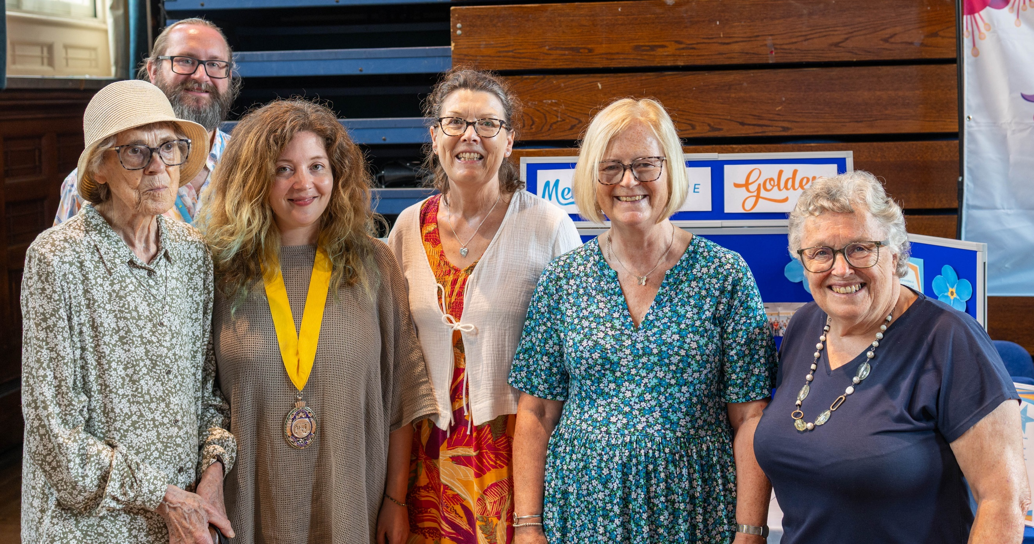

For those that contact us online, feel reassured that we will see your eConsult quickly. A senior clinician sorts through your eConsults within the hour of when they come in, and if "red flagged", faster than that. If an in-person appointment is needed, you will then be contacted and booked in, and if not, you will hear from a clinician (call or email, depending on what was needed) by the end of the next working day at the latest, unless you are notified otherwise.

Other highlights have included our role as a leading partner within an AI-supported skin lesion pathway, where we have been a trailblazer site in close collaboration with West Suffolk Foundation Trust. The project was awarded the prestigious Health Service Journal "Improving Primary Care through Digital 2025" national award, following runner-up status as "Provider Collaborative of the Year" the preceding year.

How can you help? Tell us when we have helped you, and tell us how we can improve. Think twice before responding to "GP bashing" (making jokes about access to General Practice and GP receptionists is now a national pastime…). Think about your last experience with accessing the surgery, was it recently? The average wait time for our telephone lines is under 30 seconds (from our digital telephony data), and this is because the majority of you contact us online. Thank you for this, as you are helping those that can't. Can we encourage you to leave feedback [here](https://forms.office.com/pages/responsepage.aspx?id=HEGIJCVokUOX_C5l_5YsbfW7m0x9xkVOk7HlJaMqOrlUOTdUWUtCM085VkFNU0FVWDUzNU9PT1BZTS4u&route=shorturl)

Consider joining the Patient Participation group by contacting [UnityPPGChair@suffolkfed.org.uk](mailto:UnityPPGChair@suffolkfed.org.uk) (or ask at reception)

Tell others about what we are doing, and offer optimism for the future. There are always challenges, but know that we are doing everything we can to be the best we can.

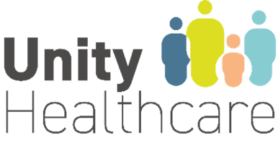

Dr David Brandon

Clinical Director, Unity Healthcare